John Galanza

5002981771

[galanj1@unlv.nevada.edu](mailto:galanj1@unlv.nevada.edu)

<https://github.com/JohnGalanza>

<https://github.com/JohnGalanza/supersmashjoe>

**Components:**

None

**Initial Code:**

.include <m328pdef.inc>

.org 0

LDI R25, 0x00 ; first 8 bits of multiplicand

LDI R24, 0x90 ; last 8 bits of multiplicand

LDI R22, 0x89 ; 8 bit multiplier

multiply:

cp R22, 0 ; check point, compares register 22 to register 0

BREQ end ; will branch to end if r22 is equal to 0

add R18, R24 ; if r22 isnt equal to 0 then it will add r18 and r24

adc R19, R25 ; if r18 and r24 have a carry it will add it here

adc R20, R0 ; if r19 and r25 have a carry then it will add it here

dec R22 ; this will decrement r22 will determine how many times we multiply

jmp multiply ; restarts loop and check point

end: jmp end

**Screen Shots**

Start of step 1

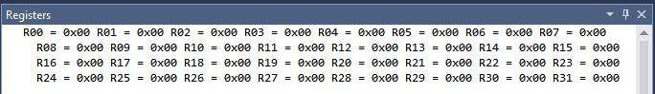

End of step 1

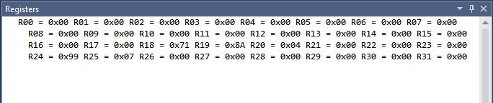

I multiplied the numbers 799 and 99 and the result is 48A71 which I verified using the calculator on my computer.

The execution time for the program was 86.38 micro seconds and the cycle count was 1382

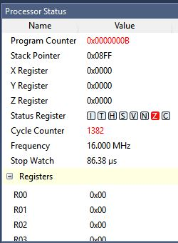

“This assignment is my own, original work.”

John Galanza